**THORPE PARK CASE STUDY**

****Employment and Skills in partnership with Business Support, WYCA and TSP consultants delivered a business engagement event for businesses based at Thorpe Park business park. The "Get to Know Your Neighbours" event, held in May 2024 was a community initiative aimed at fostering connections and collaboration among local businesses and community groups. The event featured networking opportunities, presentations on sustainability, business support, and information about the voluntary sector.

**CHALLENGES**

The local business community based at Thorpe Park lacked knowledge of other businesses in the surrounding area and therefore could not utilise the resources and connections available. This was the first event that has taken place with all Thorpe Park businesses invited so it was important to promote the event and ensure that it would be useful to all businesses in attendance.

**INTERVENTIONS**

To address these challenges, the team undertook a series of actions: Conducted a survey to identify topics of interest for businesses. Assembled a dedicated team to represent various service offerings. Held regular meetings to track progress and maintain accountability. Utilised marketing resources to create promotional materials and engage with the community through social media and direct mail. The event encouraged businesses to talk to each other and also gave them the opportunity to hear about opportunities to get involved in the business community in the future.

**OUTCOMES**

The event was a success, with over 20 businesses and community groups participating. It provided a platform for meaningful exchanges and showcased the commitment of local businesses to community and sustainability initiatives. Details of the event and its impact were shared via the newsletter to over 3000 members of the business community.

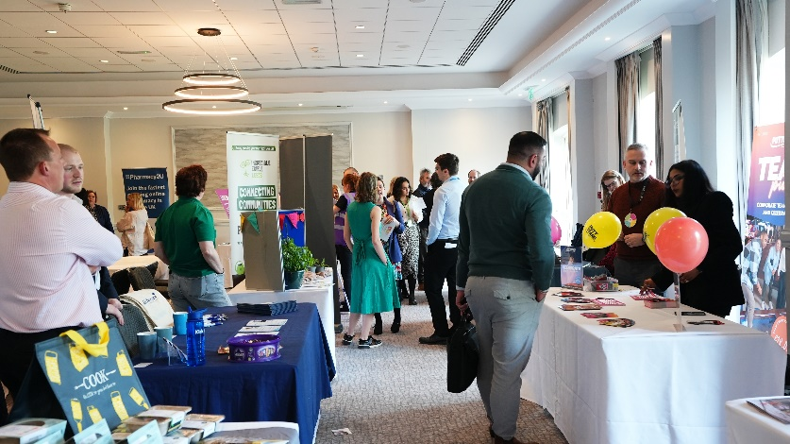**CONCLUSION**

The "Get to Know Your Neighbours" event demonstrated the value of community engagement in building a supportive and interconnected business environment. The lessons learned from this event will inform future initiatives, ensuring continued success and community development.